Notes on CSS

CSS is at best annoying, at worse a nightmare.   
  
But it’s powerful.  
  
And that’s what matters.   
  
So how does it work?  
  
CSS is intrinsically linked with HTML. When you create various blocks of HTML, they can each be styled in a very specific way. That styling is handled by CSS.  
To link them, you can put the <style> tag directly in the block, inline. (not recommended)

Or, you can define an external CSS file that handles all of the CSS’ing for you (recommended)

There are multiple ways to set a style. The basic method is by using an ID selector.

So, lets say in index.html, you have something with the ID:

<div id=”mainborder”>

TEST

</div>

To style this division, you would have an external CSS file define. Let’s say the external file is called main.css:

#mainborder{

margin:*0*;

padding:*0*;

font-size:*100%*;

vertical-align:*baseline*;

background:*transparent*;

}

To link these two, you need to have a main link decleration in your main index.html file, in your <head>:

<link href=*"css/main.css"* rel=*"stylesheet"* type=*"text/css"*></link>

You can also use a class selector to style multiple elements at once.

<div id=”main” class=”lightsoft”>Main list: … </div>

<div id=”secondary” class=”lightsoft”>Secondary List: … </div>

You can style both of these divs at once since they have the same class. In your css file, describe it like so:

.lightsoft {

margin:*0*;

padding:*0*;

font-size:*100%*;

vertical-align:*baseline*;

background:*transparent*;

}

## The box model

CSS is all about boxes. Everything is a box with CSS and HTML. When you define something, regardless of what it is, it comes in the box form that follows the convention below:

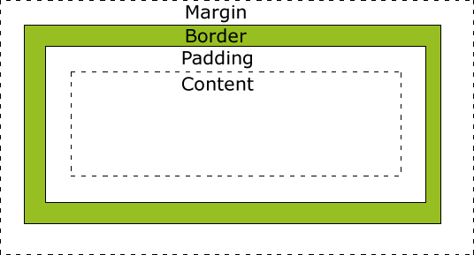

The width/height of this element is ONLY of the content; to calculate full width/height, you must add the padding, border and margins as well.

Grouping

You can group more than one element together and style them all the same by separating it with commas:

h1,h2,p  
{  
color:green;  
}

This will style all h1, h2, and p elements with the color green.

## Tags and what they do

**display:**

In general, this tag tells the text how to be displayed in the block that they are currently in. There are two options:

* Block: Take up the entire width and format it accordingly. Forces a line break.
* Inline: Take up only as much width as necessary. Does not force a line break.

**width:**

Exactly as it sound, this is the width of the element. If the element is inline display, this doesn’t do anything as inline will fill the whole width 100% of the time.

**margin:**

The margin attribute tells the element to pad the outer edge of the block with a specific amount of space that will be empty and transparent:

* auto: Let the browser choose how much to pad.
* inherit: Margins inherited form the parent.
* length: in px, specify the margins manually.
* percent: in %, specify the margins based on the width of the containing element.

You can specify each side manually using the attributes:

margin-top:100px;  
margin-bottom:100px;  
margin-right:50px;  
margin-left:50px;